Data Technician Workbook
Week 3: Databases & SQL

Name: Thamilni Paramanathan
Course Date:
Table of contents
Day 1: Task 1 3
Day 1: Task 2 3
Day 3: Task 1 4
Day 4: Task 1: Written 6
Day 4: Task 2: PostgreSQL Practical 9
Course Notes 19
Additional Information 19

Day 1: Task 1

Place/paste your ERD image here:
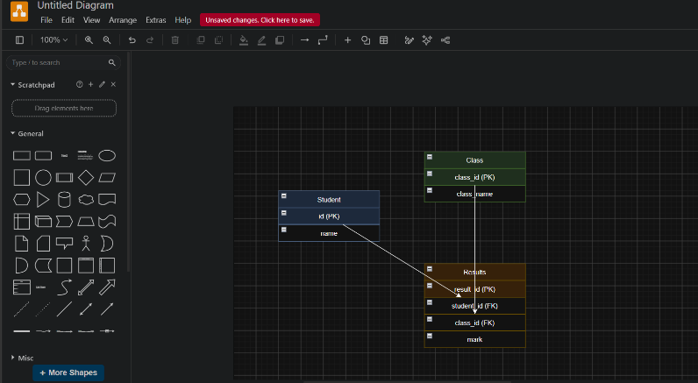

Next,

Please research and complete the questions below relating to key concepts of databases.

What is a primary key? | A Primary Key is a field that uniquely identifies each record in a table. it cannot have duplicate or NULL values.
How does this differ from a secondary key? | Primary Key: A field that uniquely identifies each record in a table. No two record can have the same primary key. Example- Passport no and Personal ID  Secondary Key: A field sued to search, sort, or group records. It does not have to be unique. So many records can have the same value.
How are primary and foreign keys related? | Primary key and foreign key are related because a foreign key refers to the primary key of another table.  - Primary key: Uniquely identifies a record in its own table.  - Foreign key: Links two tables by storing the primary key value from another table.
Provide a real-world example of a one-to-one relationship | Vehicle ---------------Registration number  - One vehicle has one registration number.  - One registration number belongs to one vehicle.
Provide a real-world example of a one-to-many relationship | Teacher --------------Students  - One teacher can teach many students.  - Each student can be assigned to one teacher.
Provide a real-world example of a many-to-many relationship | Doctors ----------- Patients  - One doctor can treat many patients.  - One patient can visit many doctors.

Day 1: Task 2

Please research and complete the questions below relating to key concepts of databases.

What is the difference between a relational and non-relational database? | Relational Database:  - Stores data in tables (rows and columns).  - Uses primary keys and foreign keys to connect tables.  - Example: MySQL, Oracle, SQL Server.  Non-relational Database (NoSQL):  - Stores data in different formats like documents, key-value pairs, graphs, or collections.  - Does not require fixed tables or relationships.  - Example: MongoDB, Firebase.  Relational Database Non-relational Database  Stores data in tables Stores data in documents, key-value, graphs, etc.  Uses Primary Key and Foreign Key Does not require fixed relationships  Fixed structure (schema) Flexible structure  Best for structured data Best for unstructured or changing data  Example: MySQL, Oracle Example: MongoDB, Firebase
What type of data would benefit off the non-relational model?  Why? | - Social media posts (Facebook, Instagram, X)  - Images and videos  - User profiles  - Online shopping product  - Customer reviews and ratings  - Chat messages  - GPS and location data  - Website click and activity logs  - Gaming data (player scores, achievements)  Because this data changes often and does not have a fixed format. A Non-relational database can store this type of data easily and handle large amounts of data quickly.

Day 3: Task 1

Please research the types of 'JOIN ' below, explain what they are and provide an example of the types of data they would be used on.

Self-join | Using the same table twice to discover relationships between the records within it.  - To identify the relationship between an employee and their manager.  - To link a category with its parent category.  - To compare records within the same table.  Employees Table (Before SELF JOIN)  employee_id employee_name manager_id  1 Ravi NULL  2 Priya 1  3 Kumar 1  4 Anu 2  SELECT e.employee_name AS Employee,  m.employee_name AS Manager FROM Employees e JOIN Employees m ON e.manager_id = m.employee_id;  Employees Table (After SELF JOIN)  employee_id employee_name manager_id  1 Ravi NULL  2 Priya 1  3 Kumar 1  4 Anu 2
Right join | RIGHT JOIN displays all records from the right table and the matching records from the left table  customer_id name  1 Ravi  2 Priya  3 Kumar  order_id customer_id product  101 1 Laptop  102 2 Phone  103 4 Tablet  SELECT Customers.name,  Orders.product FROM Customers RIGHT JOIN Orders ON Customers.customer_id = Orders.customer_id  Results  name product  Ravi Laptop  Priya Phone  NULL Tablet
Full join | FULL JOIN displays all records from both tables; a NULL value is shown for records that do not have a match.  customer_id customer_name  1 Ravi  2 Priya  3 Kumar  order_id customer_id product  101 1 Laptop  102 2 Phone  103 4 Tablet  SELECT Customers.customer_name, Orders.product FROM Customers FULL OUTER JOIN Orders ON Customers.customer_id = Orders.customer_id;  Results  customer_name product  Ravi Laptop  Priya Phone  Kumar NULL  NULL Tablet
Inner join | combines and displays only the matching records from both tables.  SELECT  Customers.customer_name,  Orders.product  FROM Customers INNER JOIN Orders ON Customers.customer_id = Orders.customer_id;  Results  customer_name product  Ravi Laptop  Priya Phone
Cross join | A CROSS JOIN is a type of JOIN that combines every record from one table with every record from the other table (Cartesian Product).  color  Red  Blue  size  Small  Large  Medium  SELECT Colors.color,  Sizes.size FROM Colors  CROSS JOIN Sizes;  Result  color size  Red Small  Red Large  Red Medium  Blue Small  Blue Large  Blue Medium
Left join | displays all records from the left table and the matching records from the right table; NULL appears where there is no match.  customer_id customer_name  1 Ravi  2 Priya  3 Kumar  order_id customer_id product  101 1 Laptop  102 2 Phone  103 4 Tablet  SELECT Customers.customer_name,  Orders.product  FROM Customers LEFT JOIN Orders ON Customers.customer_id = Orders.customer_id;  customer_name product  Ravi Laptop  Priya Phone  Kumar NULL

Day 4: Task 1: Written

In your groups, discuss and complete the activity below. You can either nominate one writer or split the elements between you. Everyone, however, must have the completed work below:

Imagine you have been hired by a small retail business that wants to streamline its operations by creating a new database system. This database will be used to manage inventory, sales, and customer information. The business is a small corner shop that sells a range of groceries and domestic products. It might help to picture your local convenience store and think of what they sell. They also have a loyalty program, which you will need to consider when deciding what tables to create.

Write a 500-word essay explaining the steps you would take to set up and create this database. Your essay should cover the following points:

- Understanding the Business Requirements:
What kind of data will the database need to store?
Customers Table -customer_id ,customer_name ,phone_number ,email ,loyalty_points

Products Table -product_id ,product_name, category, price, supplier_id
Inventory Table -inventory_id ,product_id, quantity_in_stock ,reorder_level
Sales Table -sale_id ,customer_id ,sale_id .sale_date .total_amount
Sale_Items Table -sale_item_id, product_id ,quantity ,subtotal
Loyalty program – customer membership details, rewards points.

  - Who will be the users of the database, and what will they need to accomplish?
- Owner/Manager – check sales, manage stock, and update products.
- Employees – record sales and update inventory.
- Customers – use loyalty points and receive rewards.
- Suppliers – provide product details and stock.

- Designing the Database Schema:

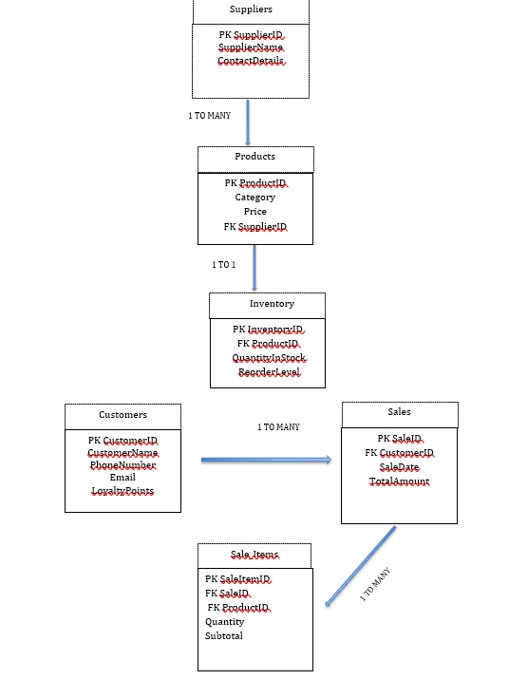
  - How would you structure/design the database tables to efficiently store inventory, sales, and customer information? Can you design it in Word doc.?

  - What type of relationship/s between tables are necessary (and can you mention the PK and FK keys) (e.g., how sales relate to inventory and customers)
• Customers (1) → (Many) Sales
• Sales (1) → (Many) Sale_Items
• Products (1) → (Many) Sale_Items
• Suppliers (1) → (Many) Products
• Products (1) → (1) Inventory
- Implementing the Database:

  - Provide examples of SQL statements for creating tables and defining relationships between them. Top 4 or 5.

CREATE TABLE Suppliers (
SupplierID INT PRIMARY KEY,
SupplierName VARCHAR(100),
SupplierContactDetails VARCHAR(150));

CREATE TABLE Products (
ProductID INT PRIMARY KEY,
ProductName VARCHAR(100),
Price DECIMAL(5,2),
StockCount INT,
SupplierID INT,
FOREIGN KEY (SupplierID) REFERENCES Suppliers(SupplierID));

CREATE TABLE Customers (
CustomerID INT PRIMARY KEY,
CustomerName VARCHAR(100),
Email VARCHAR(100),
LoyaltyPoints INT);

CREATE TABLE Sales (
TransactionID INT PRIMARY KEY,
CustomerID INT,
TransactionDate DATE,
FOREIGN KEY (CustomerID) REFERENCES Customers(CustomerID));

- Populating the Database:
  - How would you input initial data into the database tables? Can you give examples of SQL INSERT or and VALUES statements.
INSERT INTO Customers
(CustomerID, CustomerName, Email, LoyaltyPoints)
VALUES (1, 'John Smith', 'john@email.com', 120);

INSERT INTO Suppliers (SupplierID, SupplierName, SupplierContactDetails)
VALUES (1, 'Fresh Foods Ltd', '01234 567890');

- Maintaining the Database:
  - What measures would you take to ensure the database remains accurate and up to date?
To ensure the database remains accurate and up to date, Tesco Express should follow data quality procedures and use consistent data entry rules. Appropriate data types, such as INT for IDs, VARCHAR for names, DATE for transaction dates, and DECIMAL for prices, help ensure that information is entered correctly. Stock levels should be updated after every sale, and regular checks should be carried out to identify duplicate or incorrect records. Staff should also be trained to enter data consistently.
To protect the database, daily backups should be performed and stored securely. Strong passwords, user access permissions, and encryption should be used to protect customer information and prevent unauthorised access.

  - How would you handle backups and data security?
- Perform automatic daily backups.
- Store backup copies in a secure cloud location.
- Restrict database access using usernames and passwords.
- Give employees different access permissions based on their role.
- Encrypt sensitive customer information such as email addresses and phone numbers.
- Install antivirus software and keep the database software updated.

Your essay should include specific examples of SQL commands (a total of 3 or 4) and explain why each step is necessary for creating a functional and efficient database for the retail business. Do your research to find the commands and tell me what each command does – in one line.
Please write your 500-word essay here | Tesco Express is a convenience store that sells groceries, drinks, snacks, toiletries, and household products. To improve efficiency and streamline daily operations, Tesco Express could use a database system to manage inventory, sales, suppliers, customer information, and its loyalty programme. A database would help the business keep accurate records, reduce errors, and provide better customer service.  The first step in creating the database is understanding the business requirements. The database needs to store information about products, sales, suppliers, customers, and loyalty memberships. The inventory table would include fields such as ProductID (SKU), ProductName, ProductCategory, Price, StockCount, and SupplierID. The sales table would include TransactionID, TransactionDate, Quantity, and CustomerID. The supplier table would store SupplierID, SupplierName, and SupplierContactDetails. The customer table would contain CustomerID, Name, Address, ContactNumber, Email, MembershipStatus, MembershipNumber, and PointsTotal. This information enables Tesco Express to monitor stock, track sales, manage suppliers, and reward loyal customers through its Clubcard scheme.  Different employees would use the database for different tasks. Cashiers would use it to process sales and update loyalty points. Store managers would use it to monitor sales performance, generate reports, and make business decisions. Stock controllers would use the database to check stock levels and reorder products when inventory becomes low. Having a central database ensures all employees can access accurate and up-to-date information.  To design the database schema, I would create four main tables: Suppliers, Products, Customers, and Sales. The Suppliers table would use SupplierID as its Primary Key (PK). The Products table would use ProductID as its Primary Key and SupplierID as a Foreign Key (FK) linking products to suppliers. The Customers table would use CustomerID as its Primary Key. The Sales table would use TransactionID as its Primary Key and CustomerID as a Foreign Key linking sales to customers.  The relationships between the tables are important. One supplier can provide many products, creating a one-to-many relationship between Suppliers and Products. One customer can make many purchases, creating another one-to-many relationship between Customers and Sales. Primary Keys ensure each record is unique, while Foreign Keys connect related tables and maintain data integrity.  CREATE TABLE Products (  ProductID INT PRIMARY KEY,  ProductName VARCHAR(100),  Price DECIMAL(5,2), StockCount INT, SupplierID INT );  INSERT INTO Products  (ProductID, ProductName,  Price, StockCount, SupplierID)  VALUES (101, 'Milk', 1.50, 50, 1);  SELECT ProductName, Price  FROM Products  WHERE StockCount > 0;  UPDATE Products SET StockCount = 45  WHERE ProductID = 101;  1 CREATE TABLE Creates a new table with specified columns, data types, and primary/foreign keys  2 INSERT INTO Adds new records (rows) into a table, such as products or customers  3 SELECT Retrieves data from one or more tables for reports, searches, or analysis.  4 UPDATE Modifies existing records, such as changing stock levels or updating customer loyalty points.

Day 4: Task 2: SQL Practical

Please note: The first couple of queries have no errors; practice keying them manually to understand structure and syntax.

Then the following queries all have minor errors. You will need to use your AI tool to find the error and fix it, then run the query, and explain what you fixed in simple English – only one line explanation is required for each question. (Try to key the code manually where possible.)

Practice using PostgreSQL queries: Use the dataset you have already created in Supabase.
Called: World combined 30. Supabase | The Postgres Development Platform

Once completed, you can save as an SQL file: (Can also save as a CSV file if you want to.)
Go to table editor > Click on the file > click on 3 dots > Export data > Export table as SQL
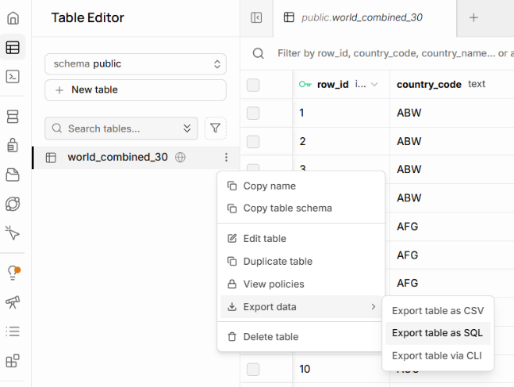
Start running these SQL queries and explain what you fixed in simple English – only one line explanation is required for each question.

Basic selection and filtering
List distinct countries in the table:

SELECT DISTINCT country_name
FROM world_combined_30;
Show all languages for Angola, ordered by percentage (highest first)

SELECT language,
language_percentage
FROM world_combined_30
WHERE country_name = 'Angola'
ORDER BY language_percentage DESC;

Find all countries where English appears as a language

SELECT DISTINCT country_name,
country_code
FROM
WHERE language = 'English';
- Added the missing table name after FROM.
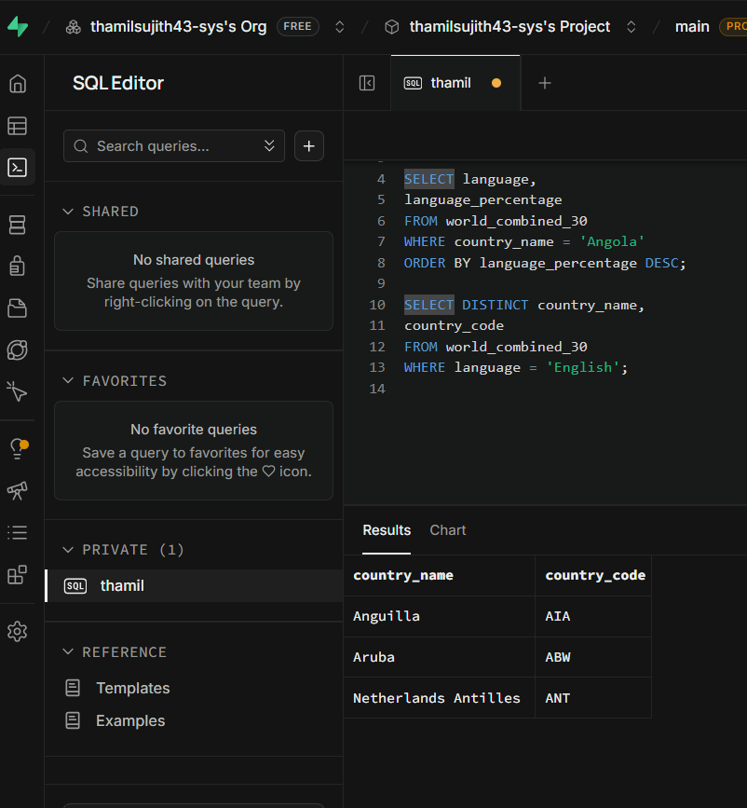

Show all non-official languages for Albania

SELECT language,
language_percentage
FROM world_combined_30
WHERE country_name = 'Albania'
AND is_official = ;
- Added FALSE to the is official condition to show only non-official languages.
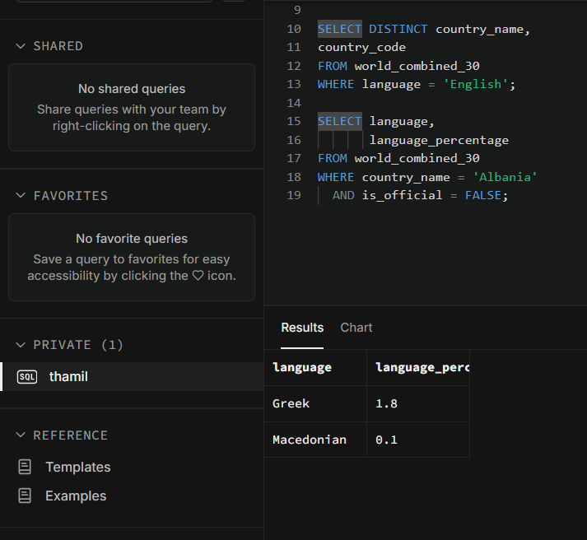

List countries whose population is between 100,000 and 3,000,000

SELECT DISTINCT country name,
Country population
FROM world_combined_30
WHERE BETWEEN 100000 AND 3000000
ORDER BY country population;
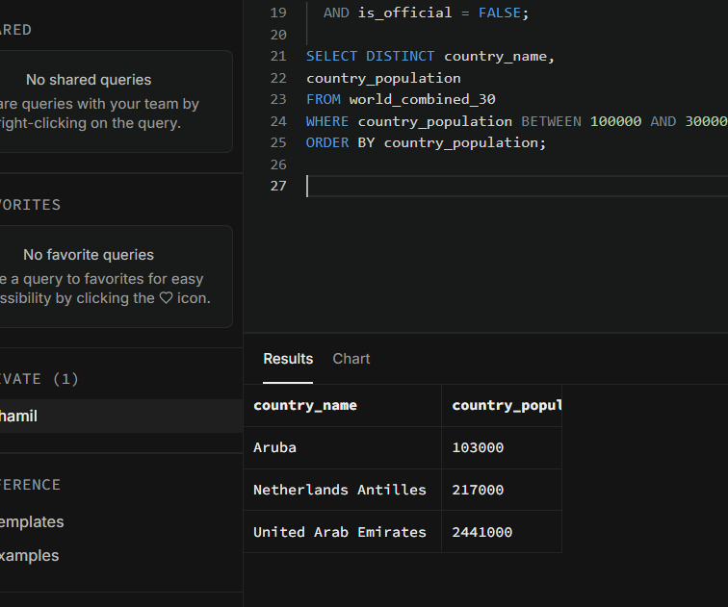
- Added the missing country population column before the BETWEEN condition.

Aggregation per country
Count how many language rows each country has in DESC order

SELECT country_name,
COUNT(*) AS language_count
FROM world_combined_30
GROUP BY country_name
ORDER BY language_count ;
- Added DESC to sort the countries
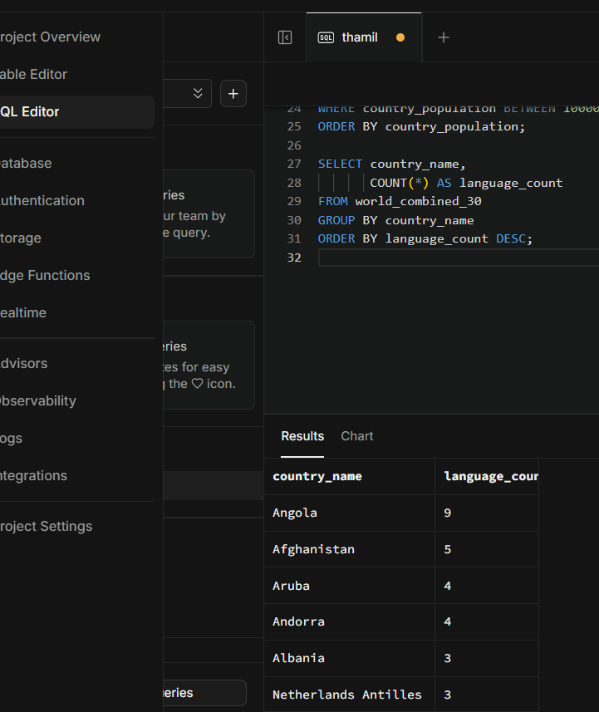

Show the maximum language percentage per country

SELECT country_name,
MAX(language_percentage) AS max_language_percentage
FROM world_combined_30
GROUP BY country_name
ORDER BY DESC;
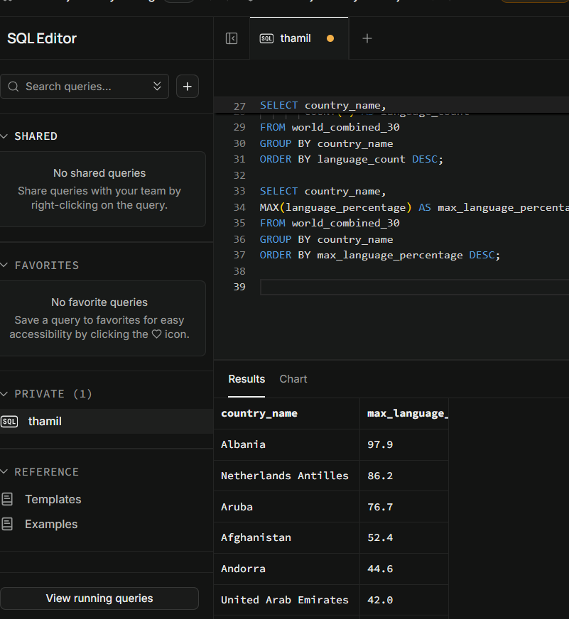
- The ORDER BY clause didn't specify which column to sort by, so I added max language percentage.

Find countries where at least one language has more than 50% share

SELECT DISTINCT country_name
FROM world_combined_30
WHERE language_percentage > 50;
- There are no errors in this query.
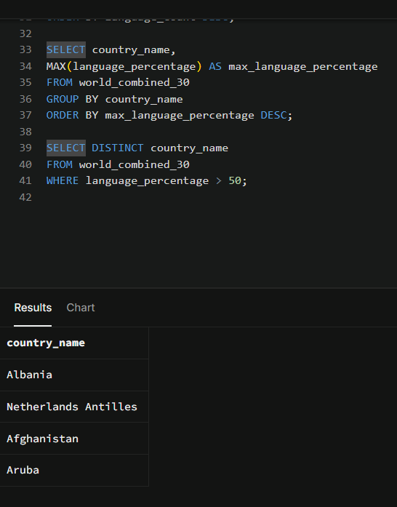

For each country, show the total percentage of official languages

SELECT country_name,
SUM(language_percentage) AS total_official_percentage
FROM world_combined_30
WHERE is_official =
GROUP BY country_name
ORDER BY total_official_percentage DESC;
- WHERE is_official = TRUE means only include official languages.
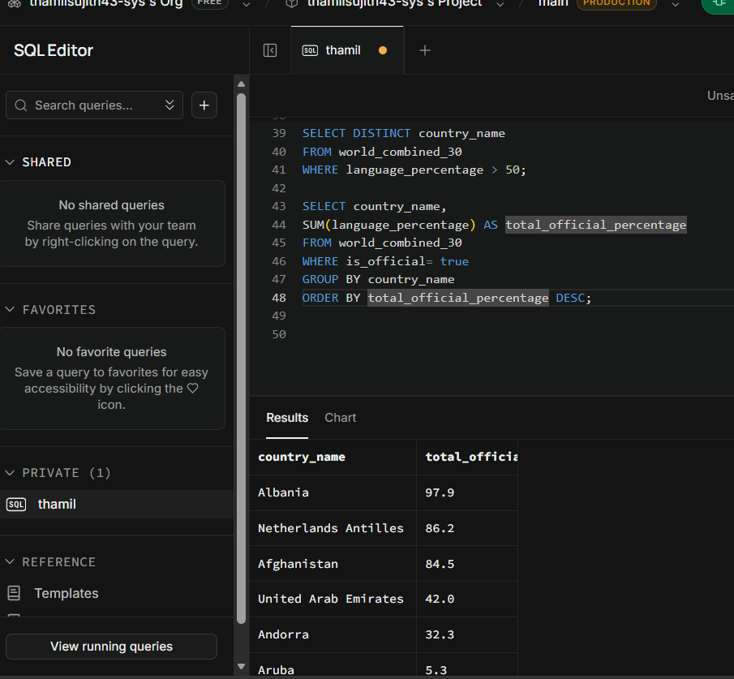

List countries that have more than one official language

SELECT country_name,
COUNT(*) AS official_language_count
FROM world_combined_30
WHERE is_official = TRUE
GROUP BY country_name
HAVING COUNT(*) > ?
ORDER BY official_language_count DESC;
- Fixed the HAVING clause by replacing? with 1 to show only countries with more than one official language.
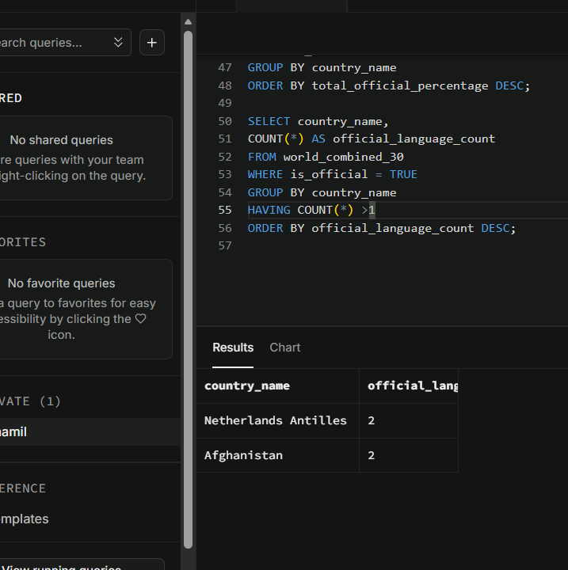

Combining filters and aggregates
Show official languages where the percentage is under 10%

SELECT country_name,
language,
language_percentage
FROM world_combined_30
WHERE is_official = TRUE
AND language_percentage;
- Added < 10 to show languages below 10%.
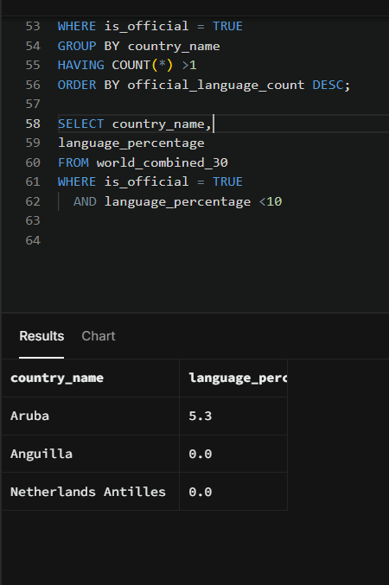

Find the country where Arabic is official

SELECT country_name,
country_code,
language_percentage
FROM world_combined_30
WHERE language = ' '
AND is_official = ;
- Added Arabic and TRUE to find countries where Arabic is an official language.
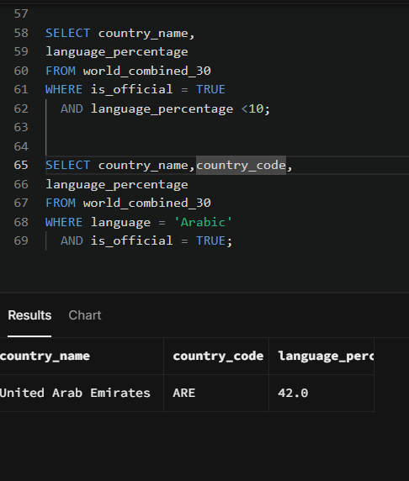

For each country, show the number of non-official languages

SELECT country_name,
COUNT(*) AS non_official_count
FROM world_combined_30
WHERE is_official =
GROUP BY country_name
ORDER BY non_official_count DESC;
- Added FALSE to the WHERE clause.
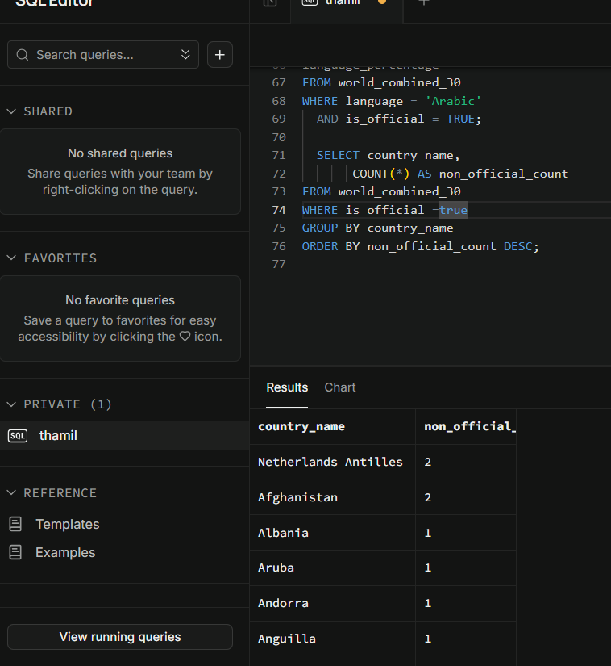

List all rows where the city name contains the word ‘la’ (case-sensitive)

SELECT *
FROM world_combined_30
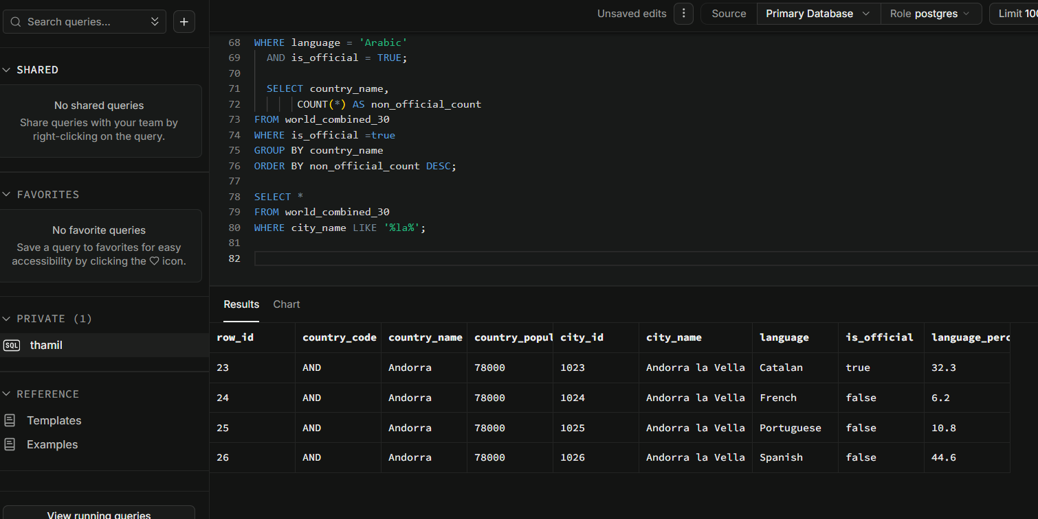
WHERE city_name LIKE '%%';

Show countries whose most spoken language (max %) is not official

SELECT country_name
FROM world_combined_30
WHERE language_percentage = (
SELECT MAX(w2.language_percentage)
FROM world_combined_30 AS w2
WHERE w2.country_name = world_combined_30.country_name)
AND is_official = ;
- I added FALSE to find non-official languages.
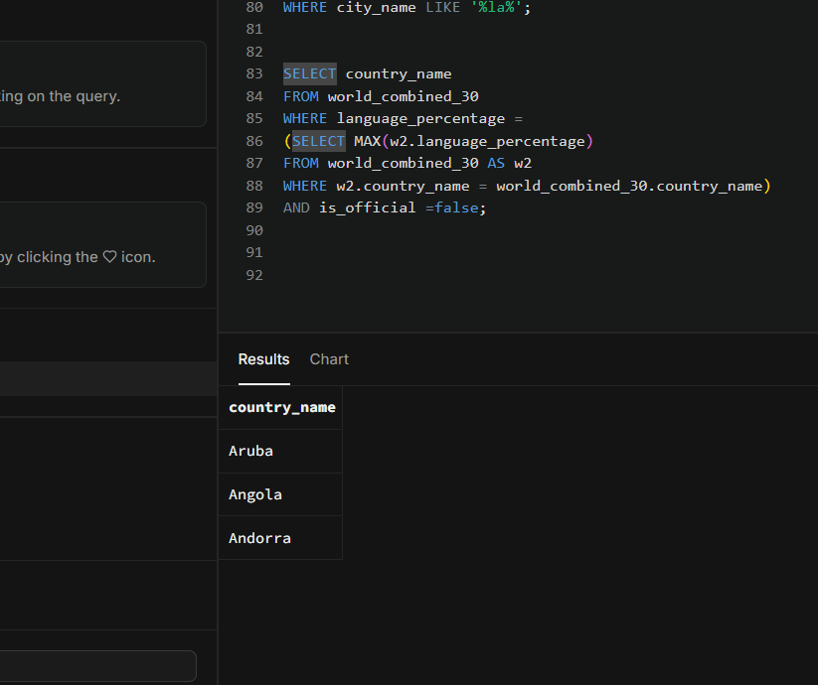

Subqueries:
List countries with population above the overall average population
SELECT DISTINCT country_name,
country_population
FROM world_combined_30
WHERE country_population >
(SELECT AVG(*)
FROM world_combined_30);
- Used AVG(country_population) to calculate the average population.
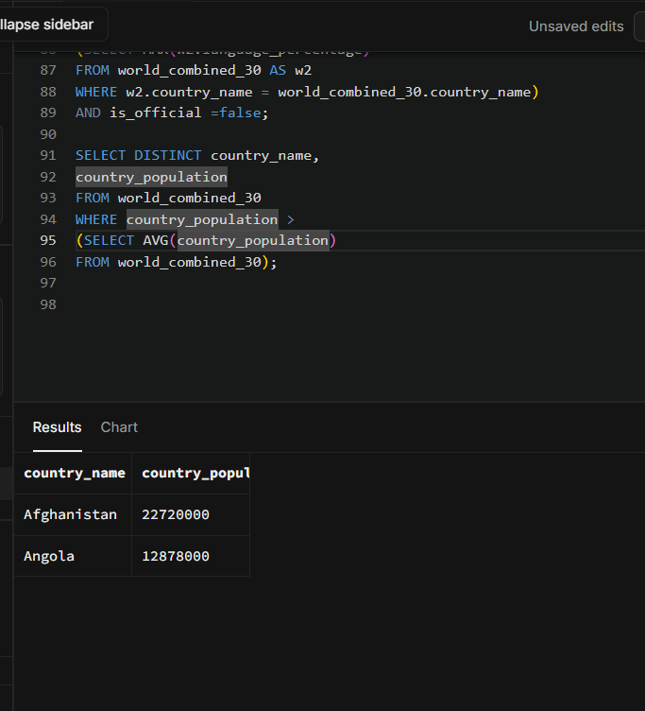

Show languages that are official somewhere and have ≥ 40% in that country

SELECT DISTINCT language,
country_name,
language_percentage
FROM world_combined_30
WHERE is_official =
AND language_percentage >=
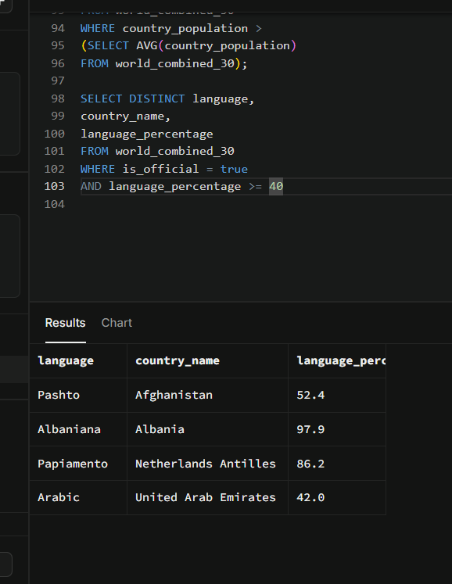
- Added TRUE for official languages and 40 to filter languages spoken by at least 40% of the country.

ORDER BY language;
Find countries whose total percentage of all languages is < 100 (data quality check)
Drag selected lines of code and then run, if need be.

SELECT country_name,
SUM(language_percentage) AS total_language_share
FROM world_combined_30
GROUP BY country_name
HAVING SUM(language_percentage) <
ORDER BY total_language_share;
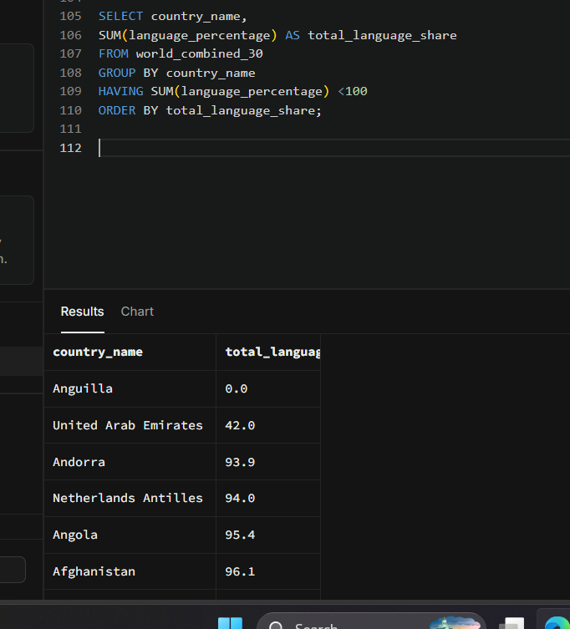
- Added 100 in HAVING to find countries where total language percentage is less than 100.

Show rows where the city appears in a country with more than 5 languages
Drag selected lines of code and then run, if need be.

SELECT *
FROM world_combined_30 AS w
WHERE country_name IN (
SELECT country_name
FROM world_combined_30
GROUP BY country_name
HAVING COUNT(*) > ?);
- Added ‘5’ to find countries that have more than 5 languages
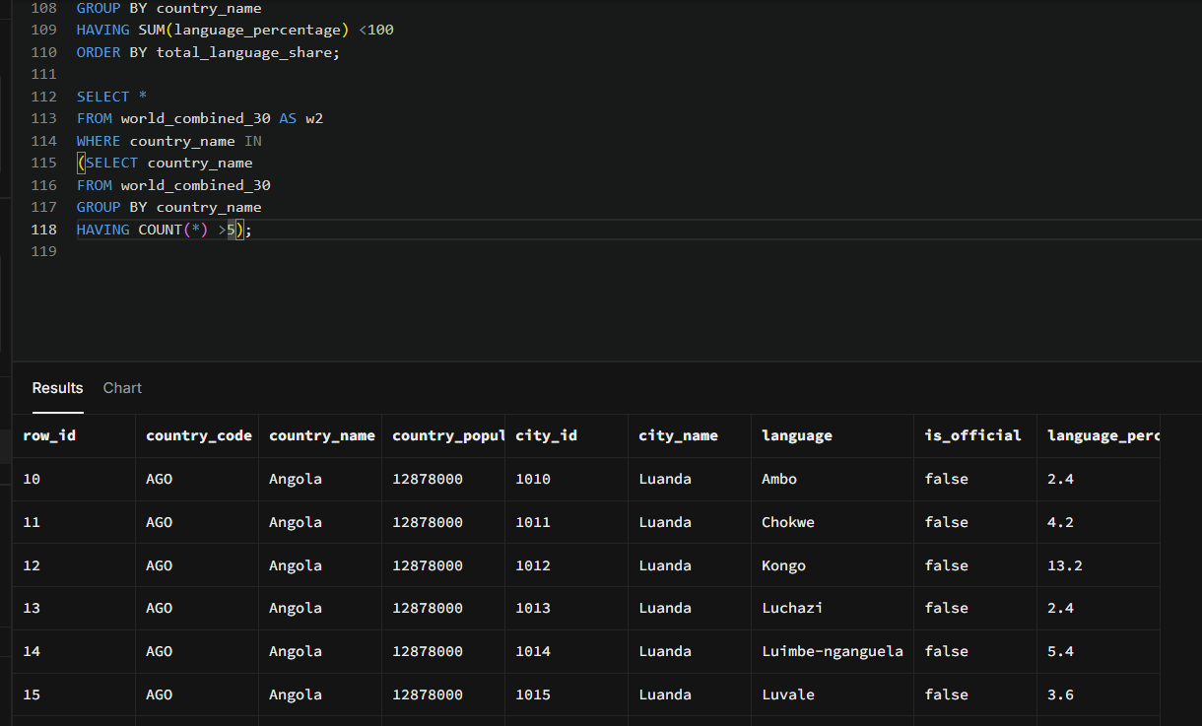

Course Notes

- SQL (Structured Query Language) is a language used to store, manage, and retrieve data from databases.
- SQL syntax means the rules and structure used to write SQL commands correctly.
- SQL data types
  - String ------ Char, varchar
  - Number----------- Int, Decimal
  - Date and time------------ Date, time

SQL LOGICAL OPERATORS

BETWEEN | TRUE if the operand is within the range of comparisons
AND | TRUE if all the conditions are separated by AND is TRUE
OR | TRUE if any of the conditions are separated by OR is TRUE
IN | TRUE if the operand is equal to one of a list of expressions
NOT | Displays a record if the condition(s) is NOT TRUE

- WHAT IS A SUBQUERY?
  - A query within a query
GROUPING DATA
JOINING TABLES
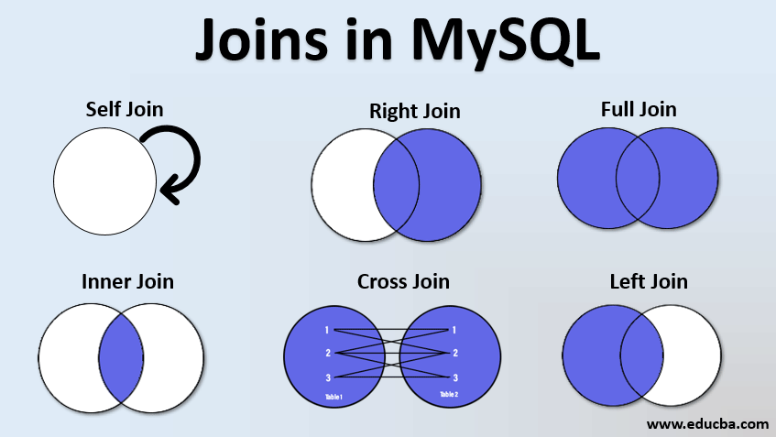

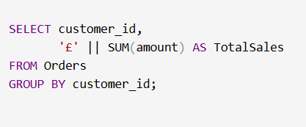
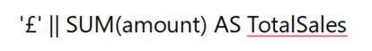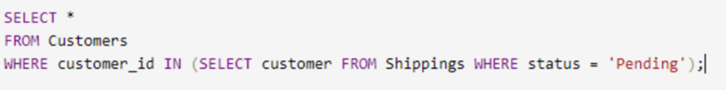
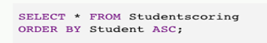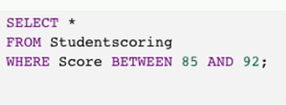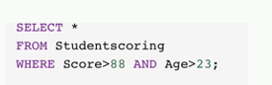
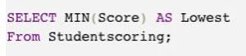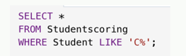

It is recommended to take notes from the course, use the space below to do so, or use the revision guide shared with the class
Additional Information

We have included a range of additional links to further resources and information that you may find useful, these can be found within your revision guide.

END OF WORKBOOK

Please check through your work thoroughly before submitting and update the table of contents if required.

Please send your completed work booklet to your trainer.

